Team 2

User Guideline

Organocity (Team 2)

Amit Kumar Karn

Saurav Shrestha

Yogesh Shrestha

Kritika Thapa

Saugat Adhikari

Kritika Thapa

Customer

1. Customers can browse the website and add items to the cart.
2. Click the Register button if you are a new user and Login if you have registered previously on the website.

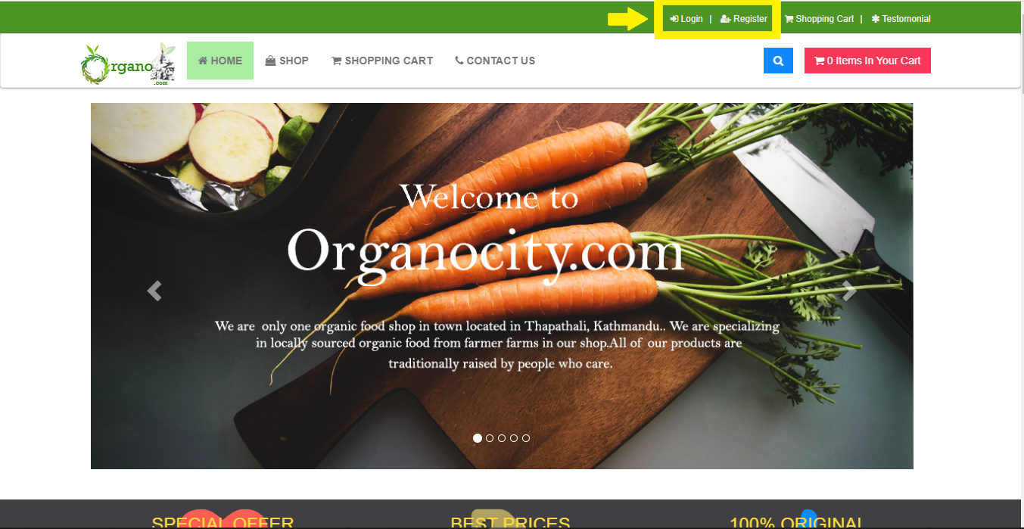

1. Sign Up by filling the provided form to be registered as a new User.

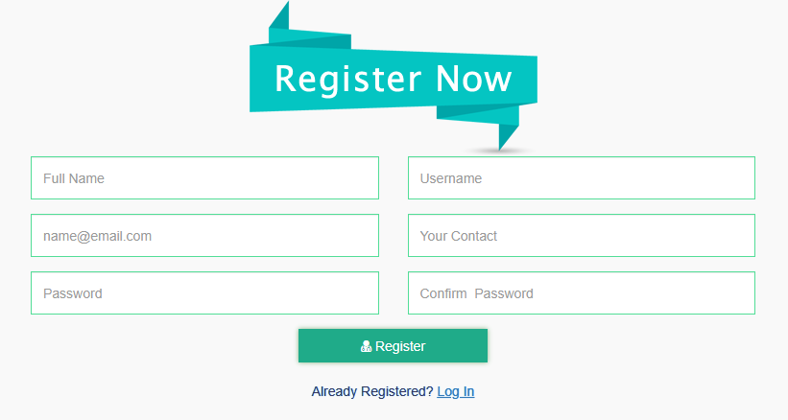

1. Customers can then login into the website after verification using their Username and Password.

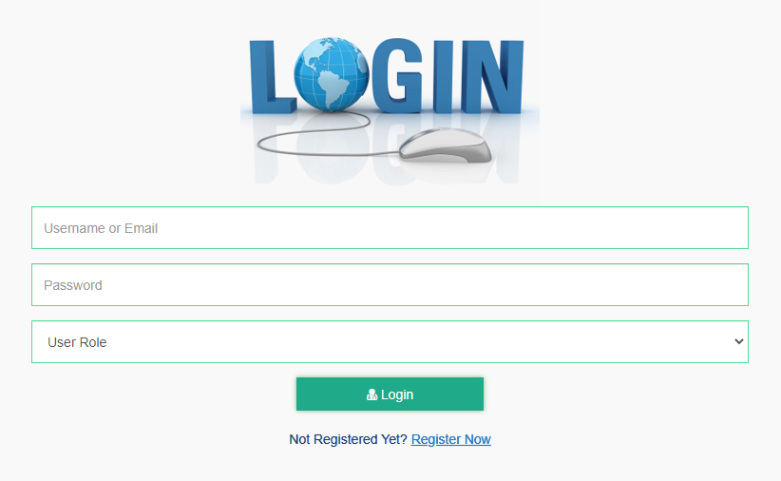

1. A ‘Not Verified’ message will be displayed in the account profile.

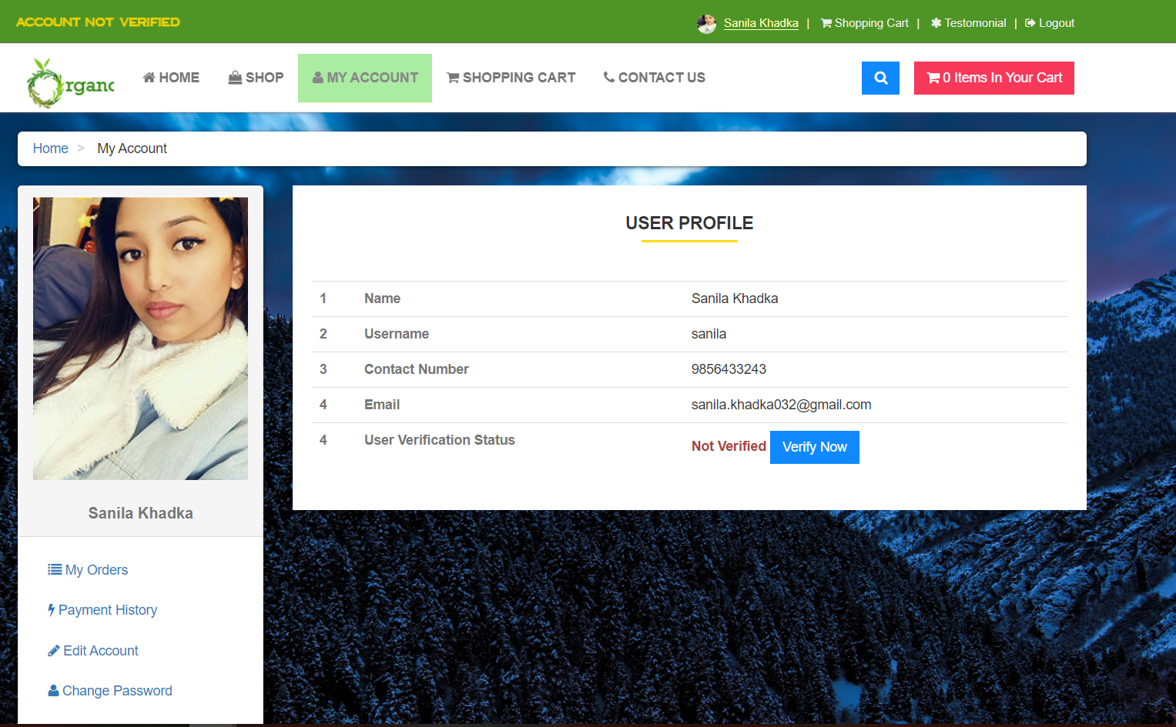

1. Products will be added to the cart but the user won’t be able to checkout without verifying email.

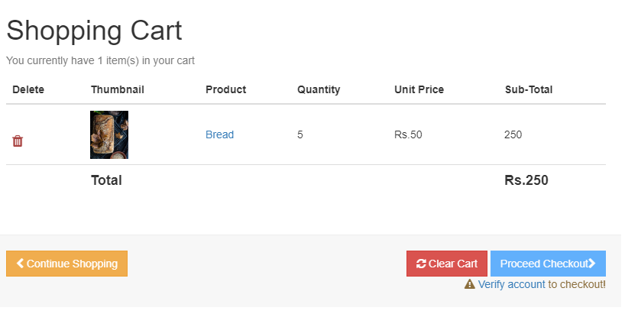

1. After user clicks verify now button in my account, they will be redirected to this page which sends a verification link to the user’s email.

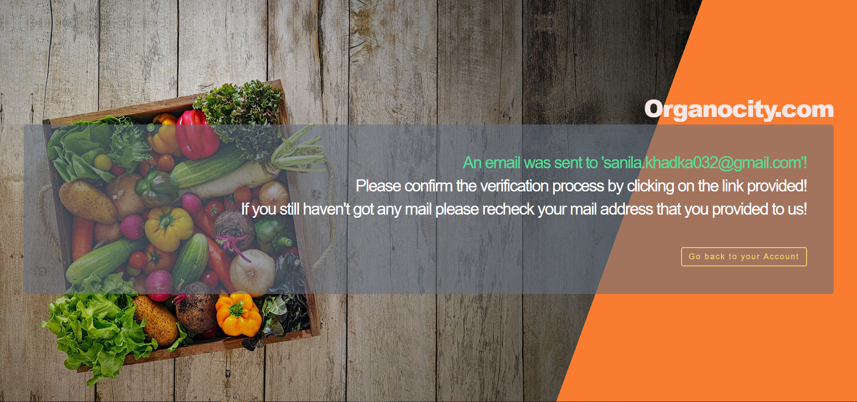

1. The user get a verification link in their email.

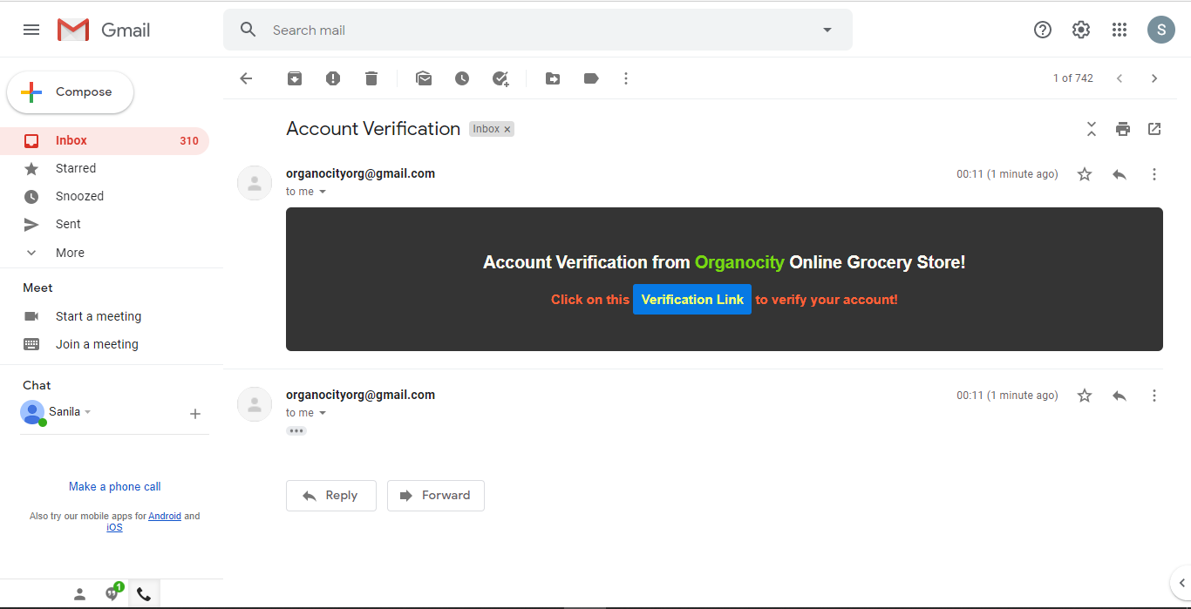

1. After clicking the verification link, the user will be redirected to verification success page and users account will be activated.

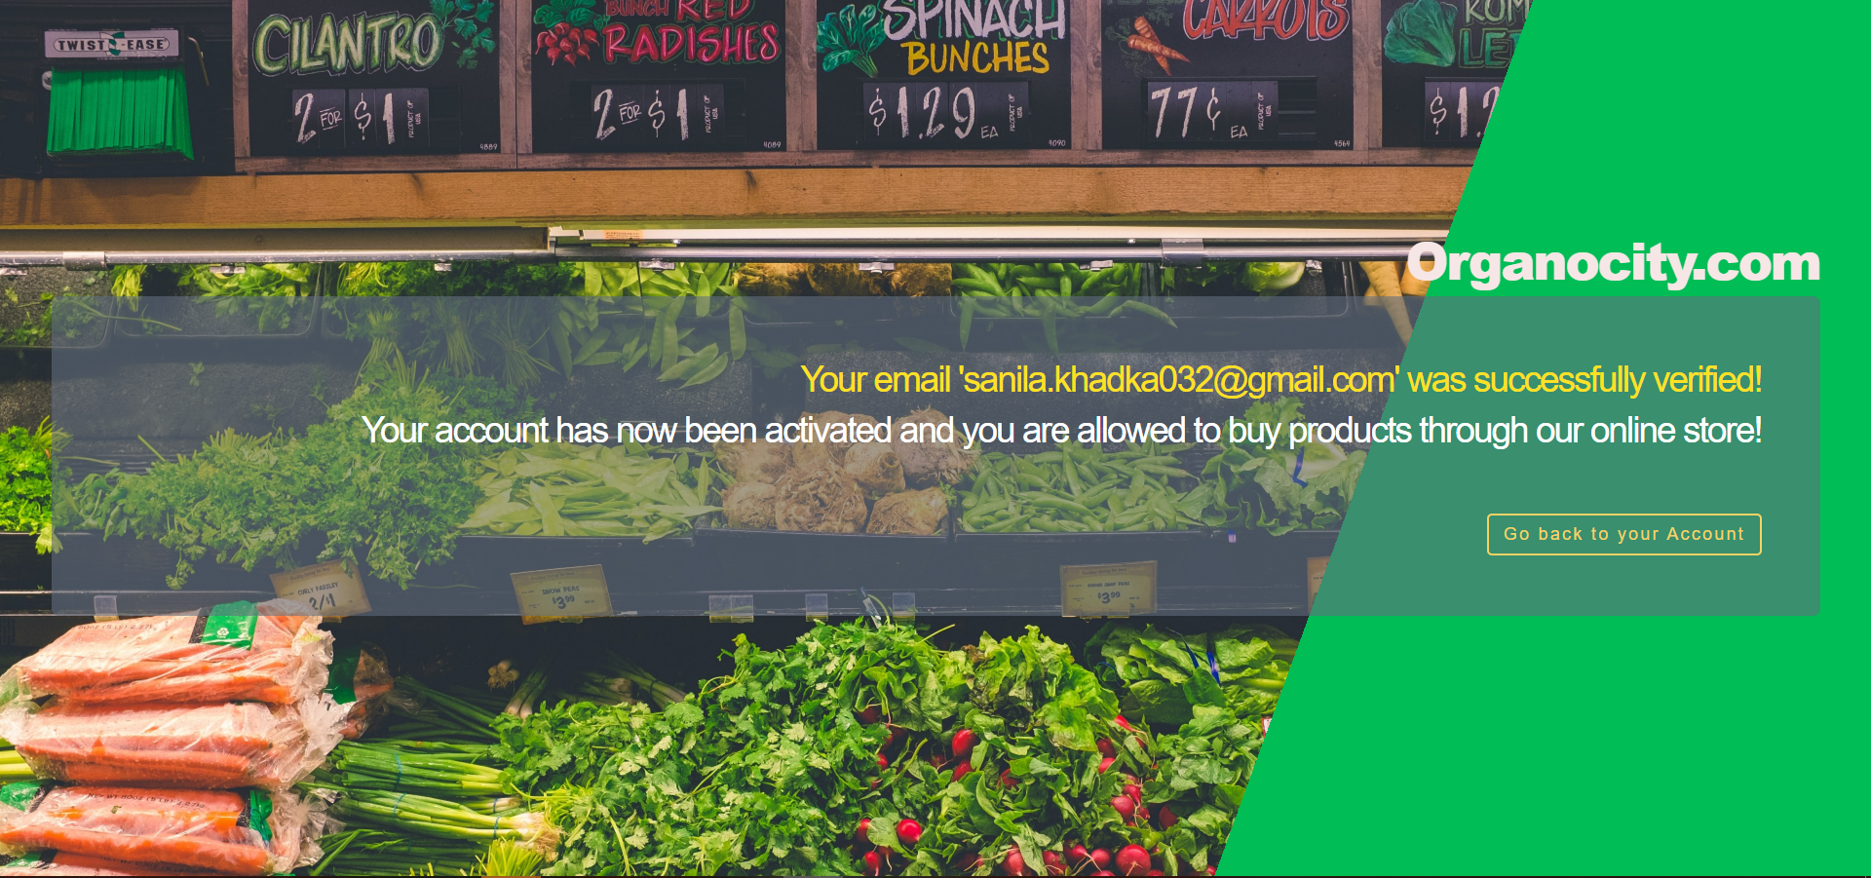

1. The user’s account is now activated and verified.

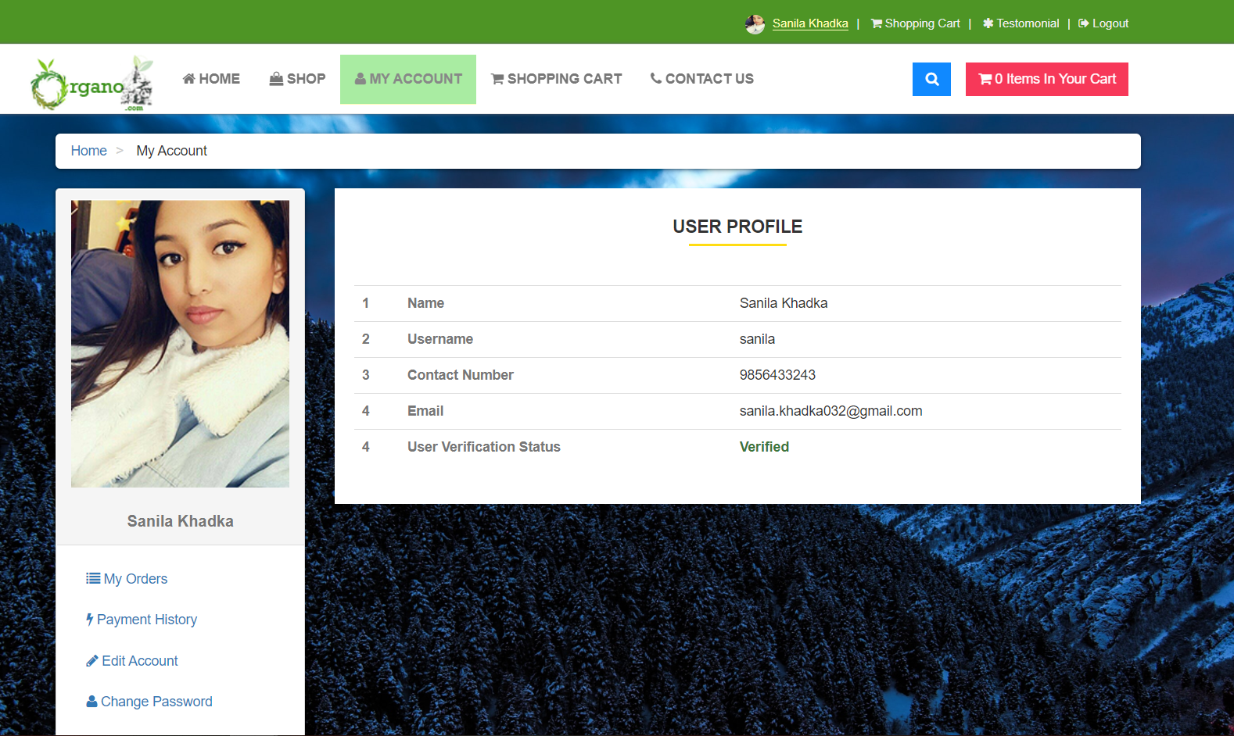

1. Users can access their profiles to update details, upload profile photos and check orders.

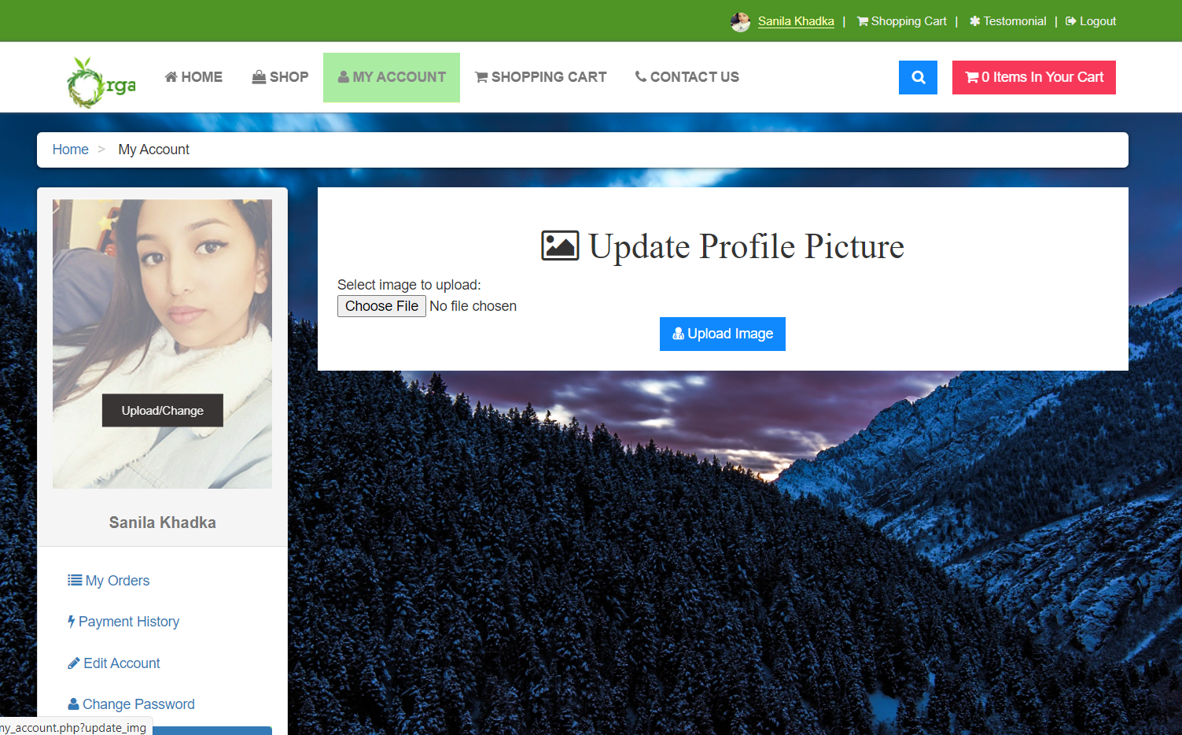

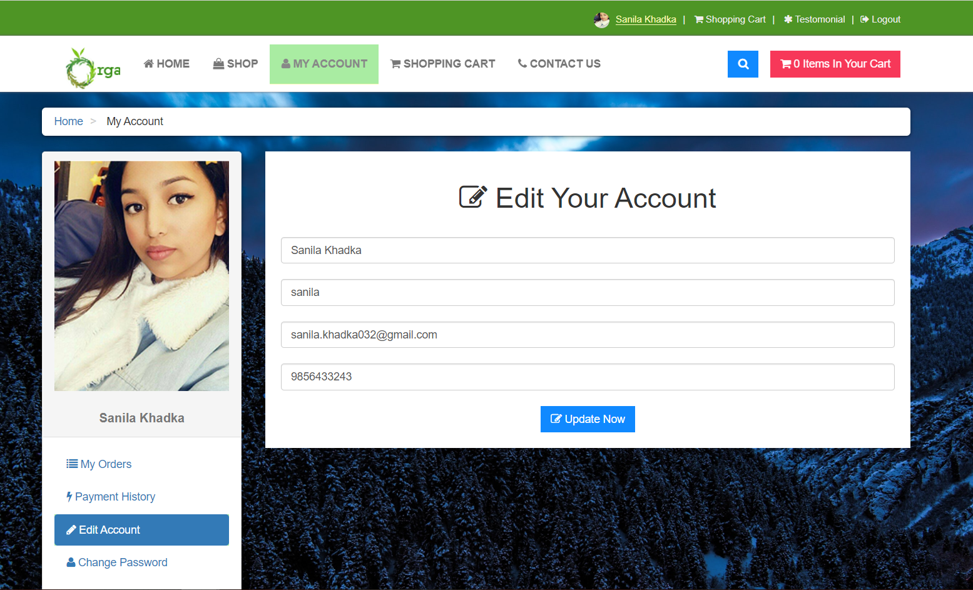

1. Customers can browse different pages of the website to view items to purchase and add the items to cart.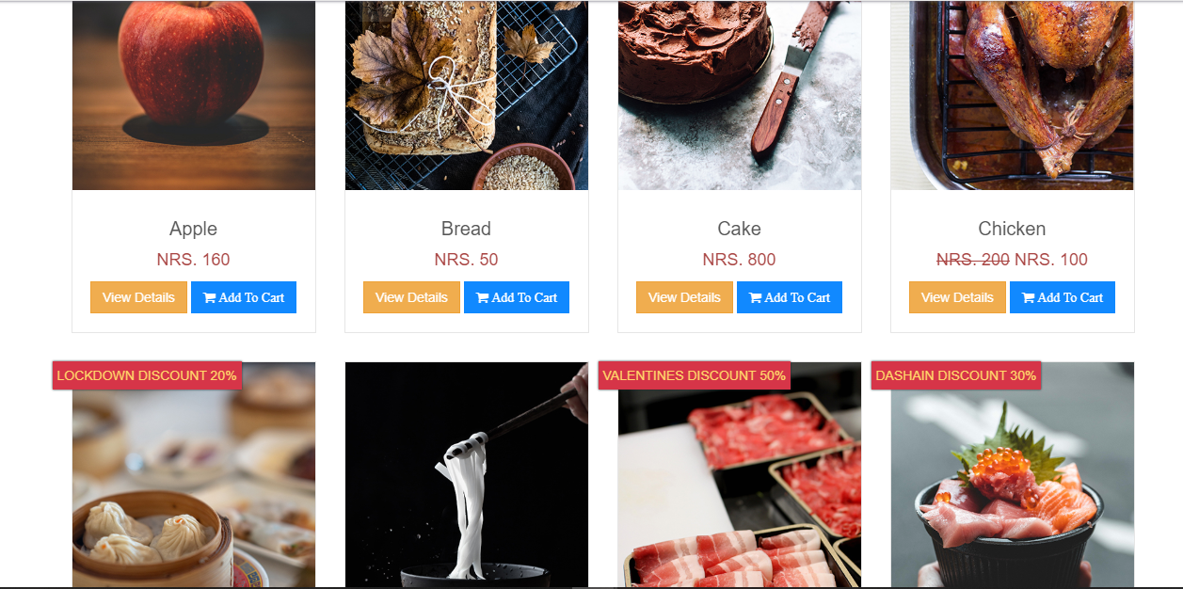
2. Adding to cart is done by pressing the Cart symbol which appears while hovering on an item.

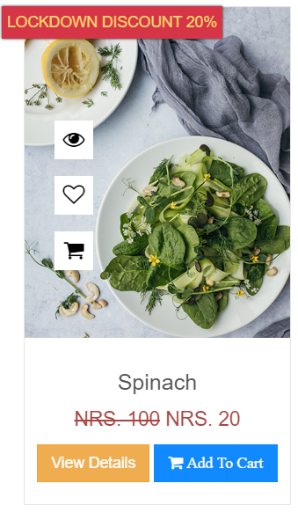

1. Items with discounts are also displayed on the home page.

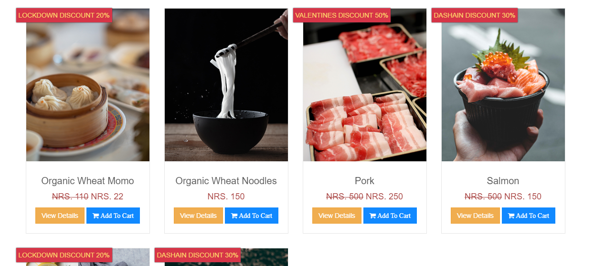

1. Customers can dynamically search for specific products.

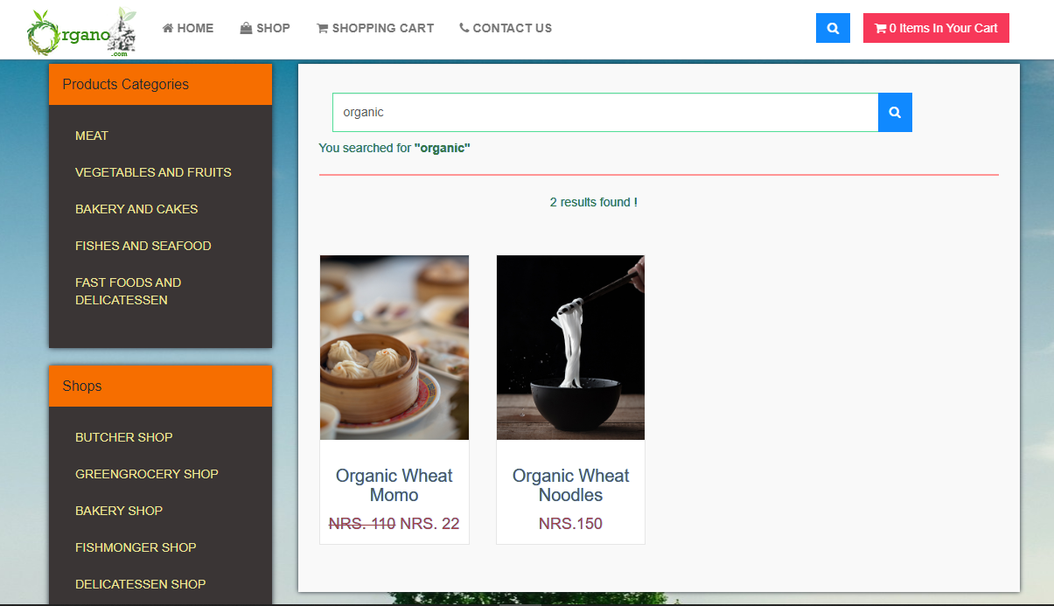

1. Customers can also click Shop and view items based on categories.

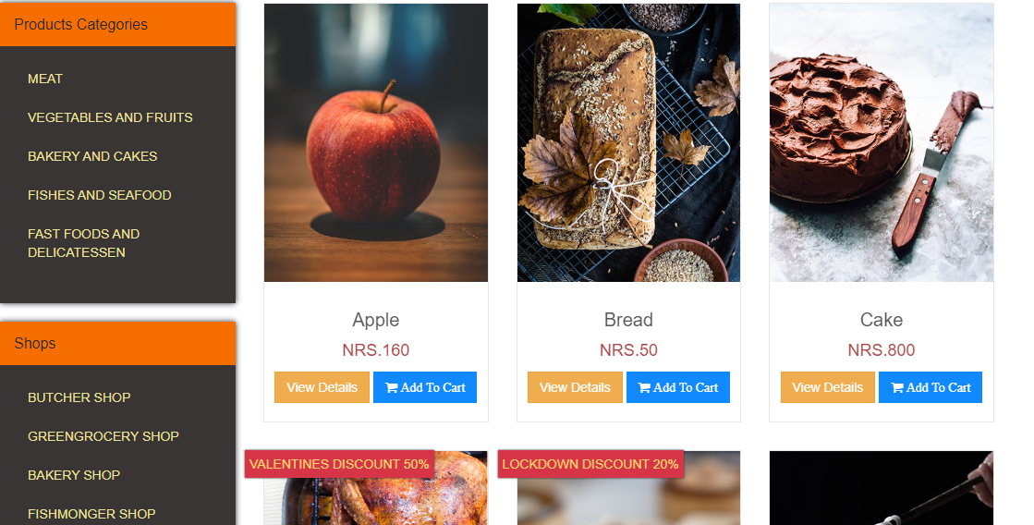

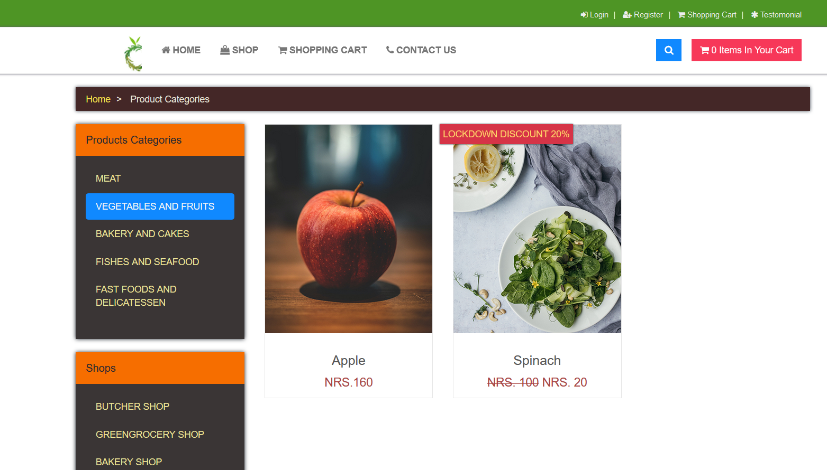

1. Products can be sorted via alphabet or price (high to low or vice versa)

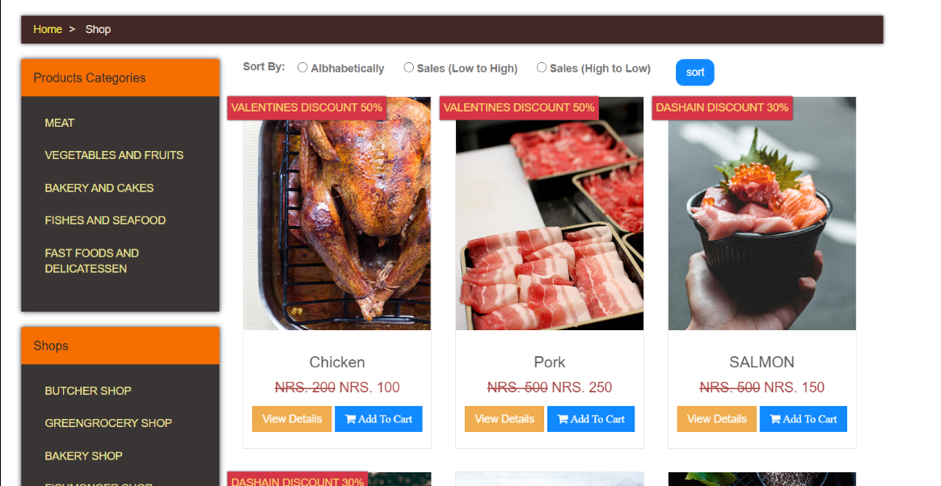

1. Various contact information and location data is provided in case of inquiry.

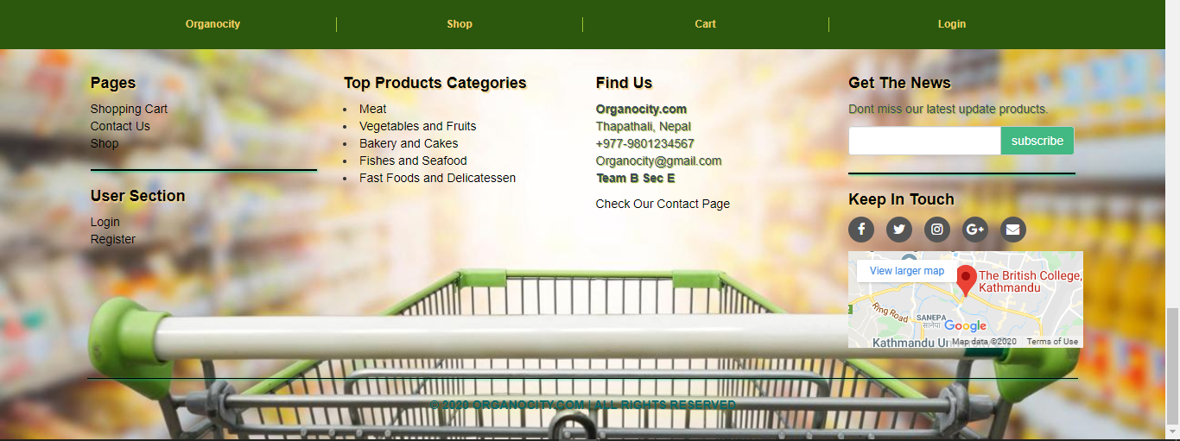

1. A description of the product can also be seen by clicking View on the product.

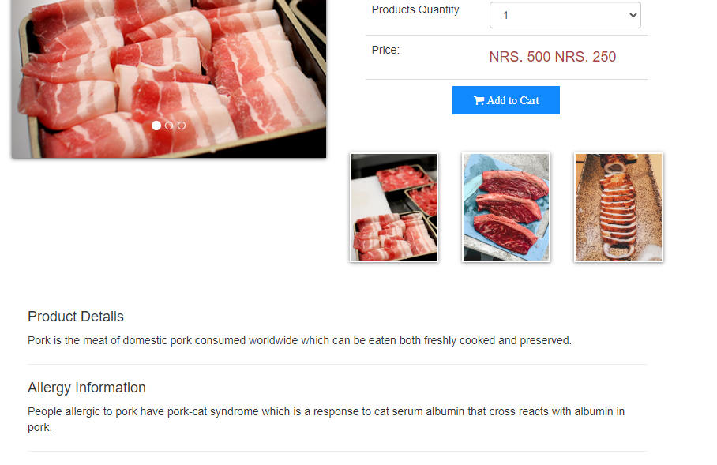

1. Customers need to be logged in before accessing cart.

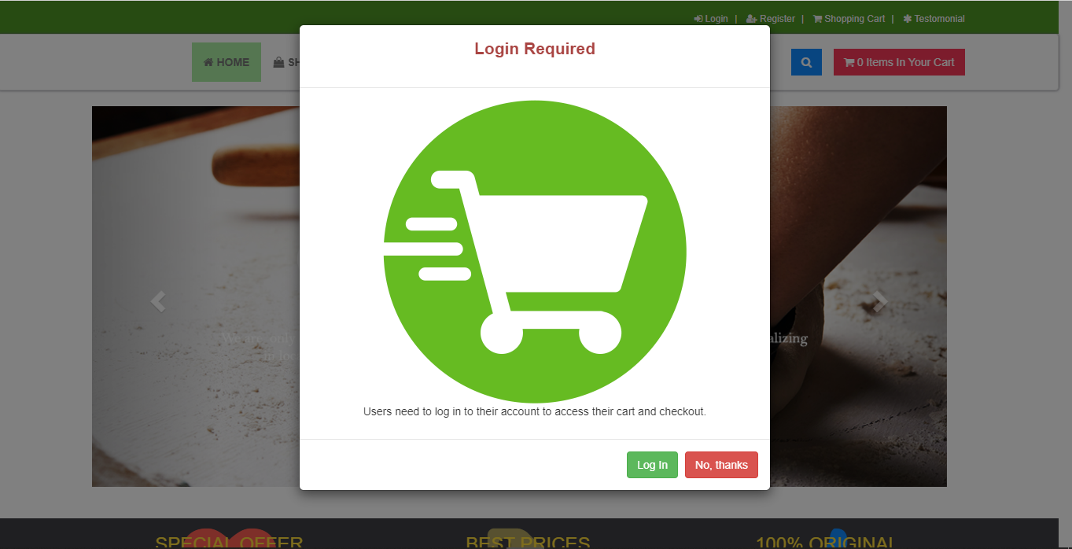

1. In the cart, Customers can view all the items added, the quantity and the total price to be paid.

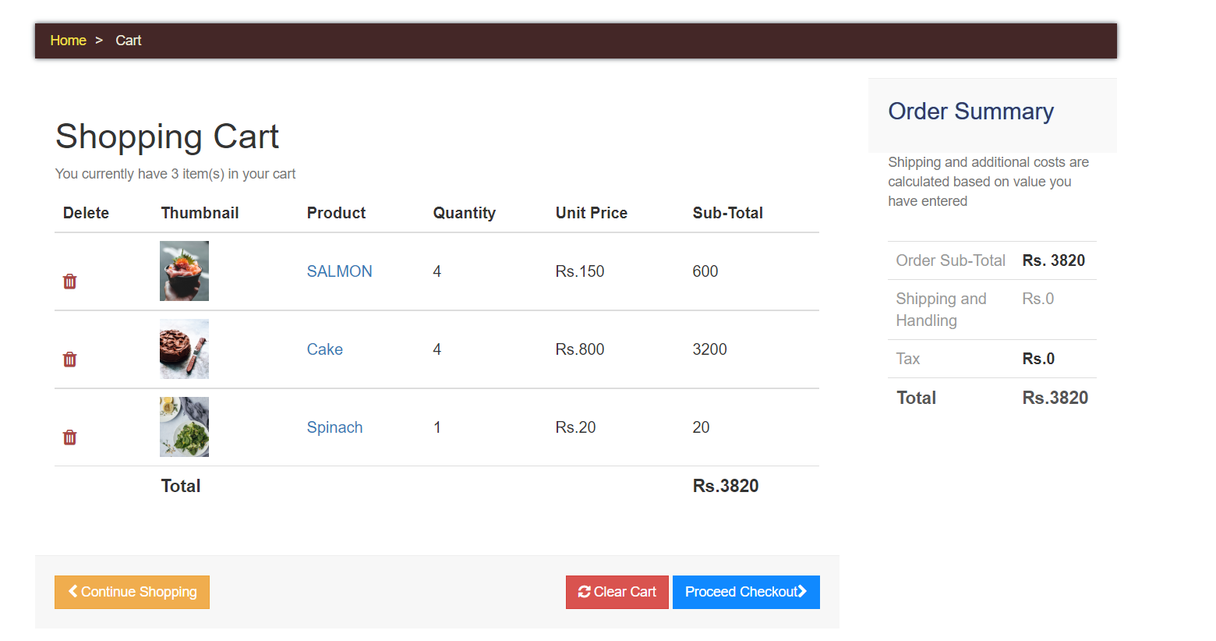

1. Customers can remove items, add quantity of products and proceed to checkout by pressing the Checkout button.

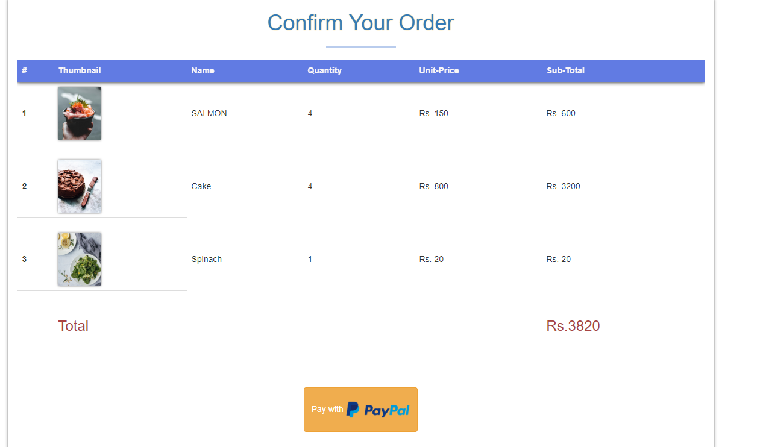

1. Customers are redirected to the PayPal sandbox where their ID and Password need to be entered.

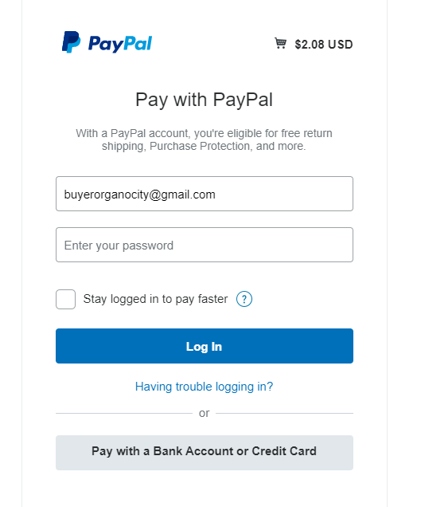

1. Once logged in, Customers are provided with 2 options: PayPal balance and MasterCard. After choice is made, Customers can press the Pay Now button to confirm payment.

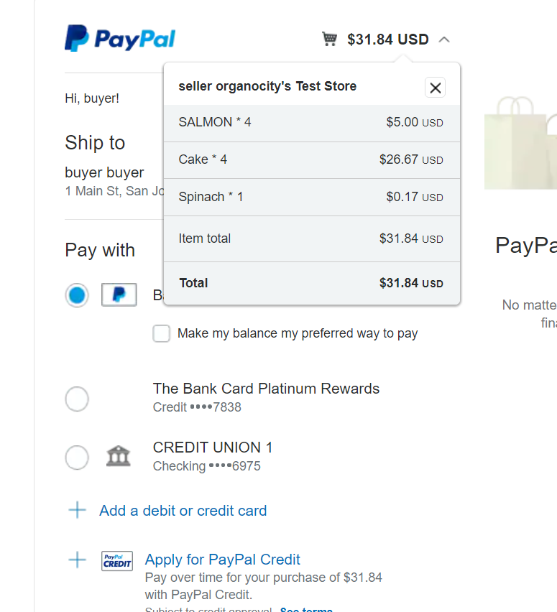

1. After payment is made, collection slot choice is made to pick up the item.

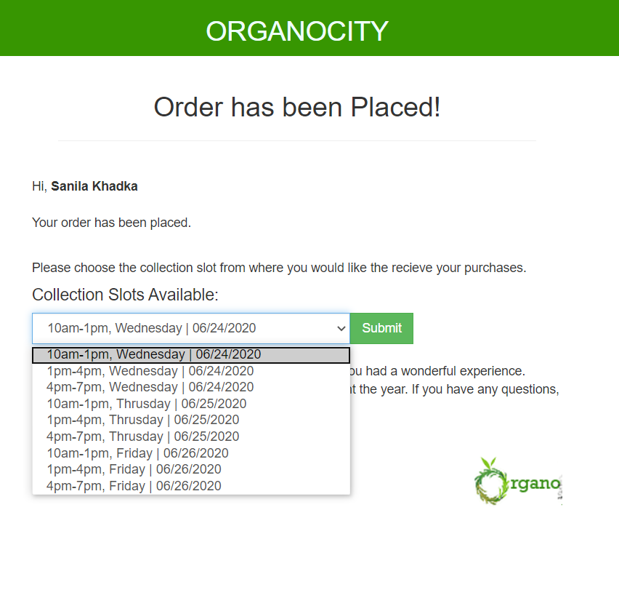

1. The order has been placed and the collection slot and order details will appear.

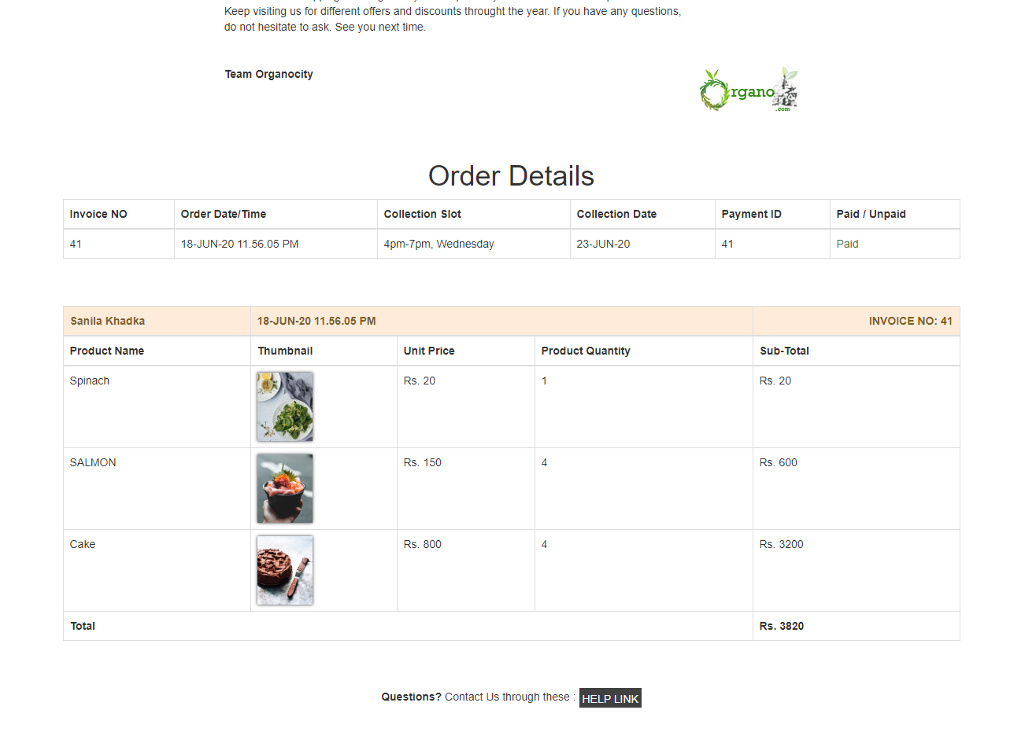

1. Customers will receive a receipt of their purchase through email containing all items ordered, collection slot, receipt number and payment details.

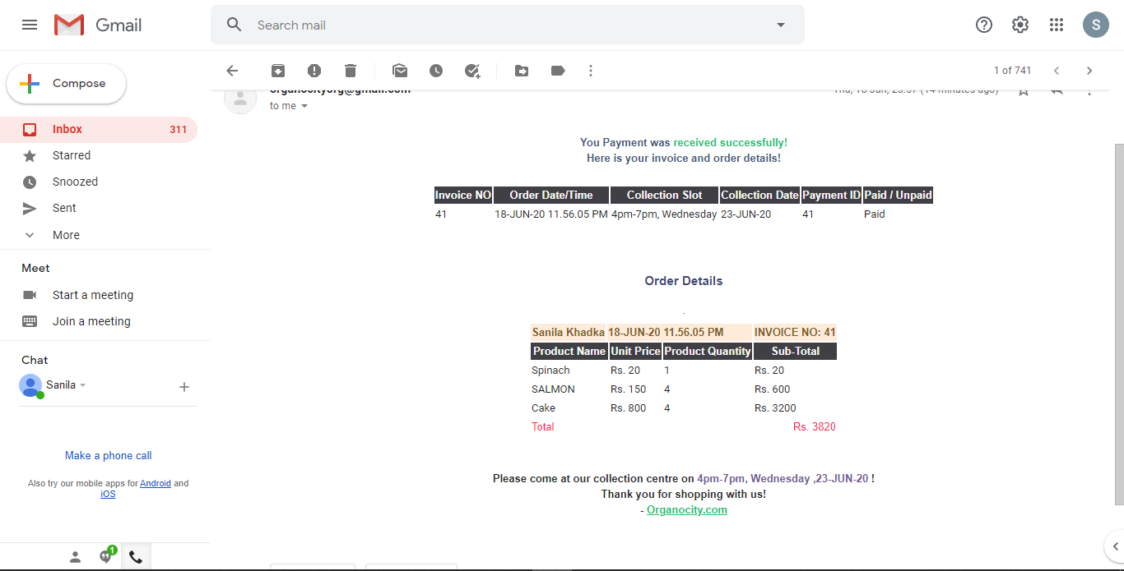

1. Customers can also review and rate the products.

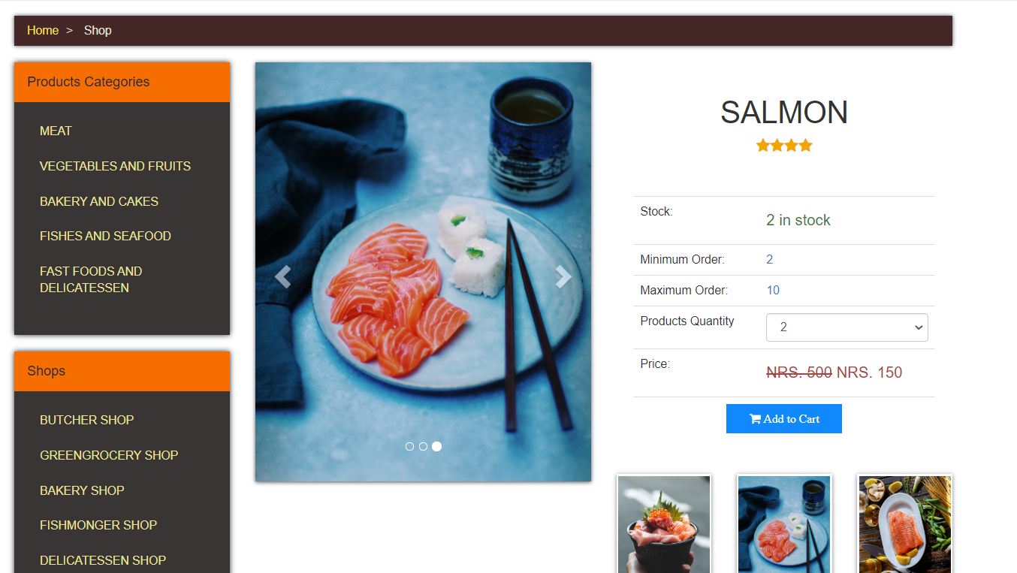

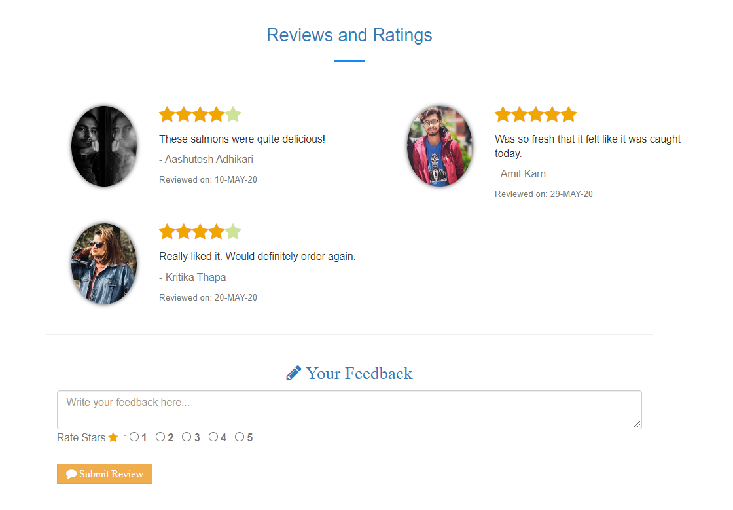

1. The same process needs to be repeated in the case of buying another product.